**SCAG CODES ALIGNMENT WITH RESPECTIVE COLOR CODES:**

1. Check for Land Use data in the county this attribute describes the use of land for example for agriculture, business or residential for single family homes, or multi residential homes most of the time this attribute will be labeled using a different name or code in my case the field name was labeled as CDLIT_1 which I later changed it to LandUSe

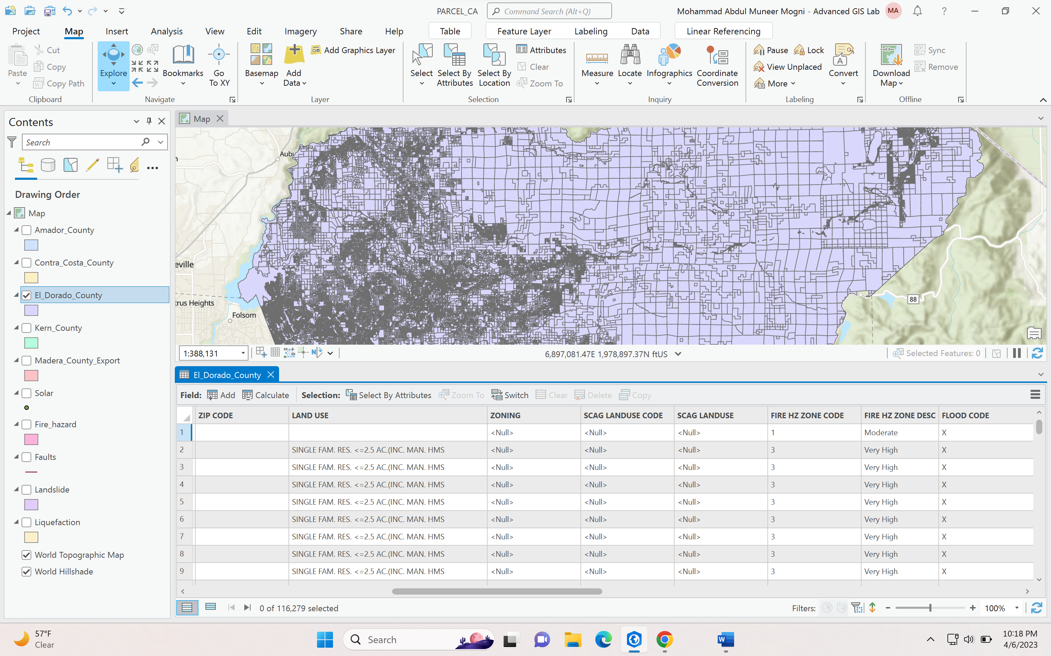

1. Go to Select by Attributes select the county:

**where clause is equal to single family** use this code to select one type of land use

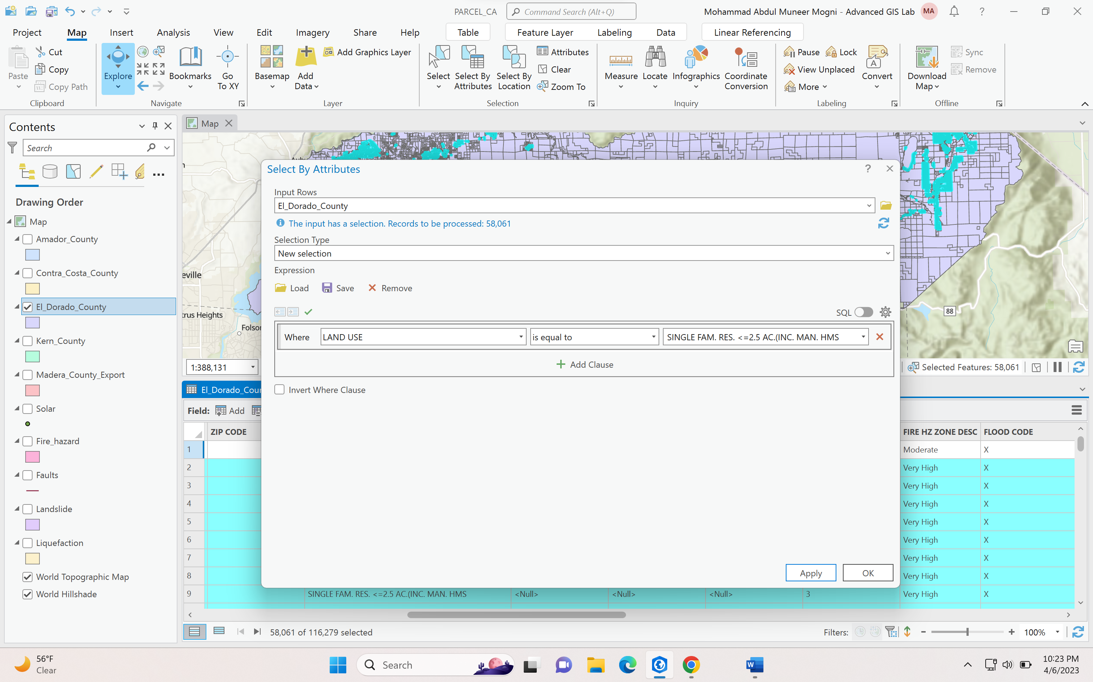

1. SCAG LAND USE CODE ATTRIBUTE FUNCTION

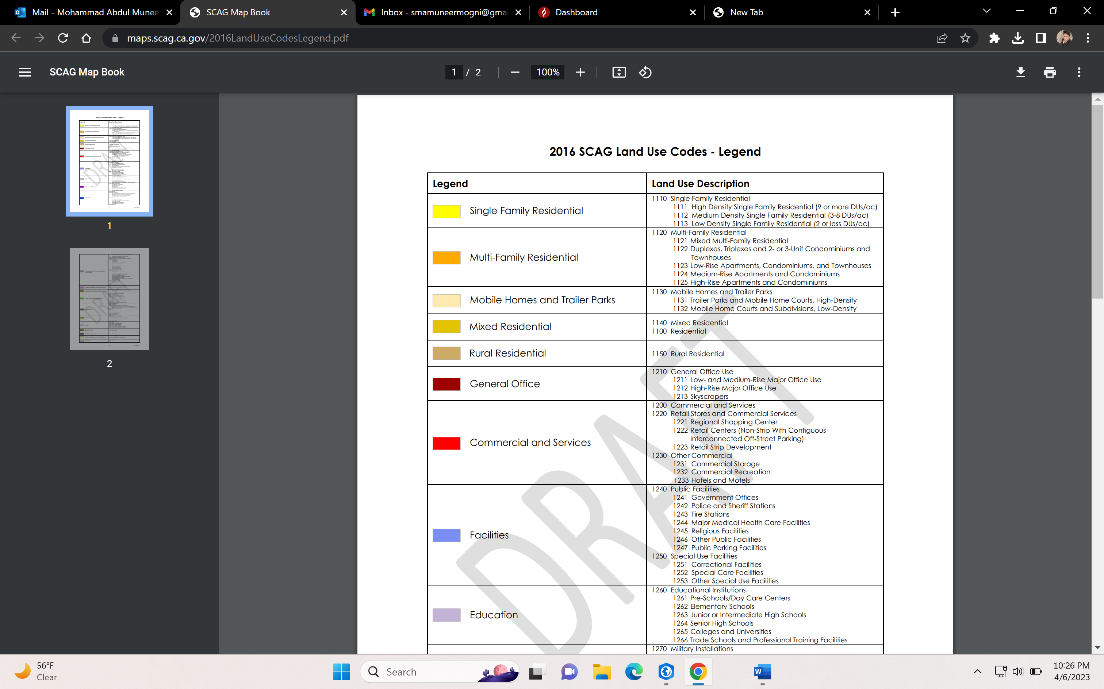

So for Single Family home the codes is 1110

Go to Calculate field after selecting all single family homes

Keep the county as it is

Select the field to SCAG_LUCO for SCAG LAND USE CODE or if you don’t have this field create a field name called SCAG_LUCO

Insert the field value code = 1110

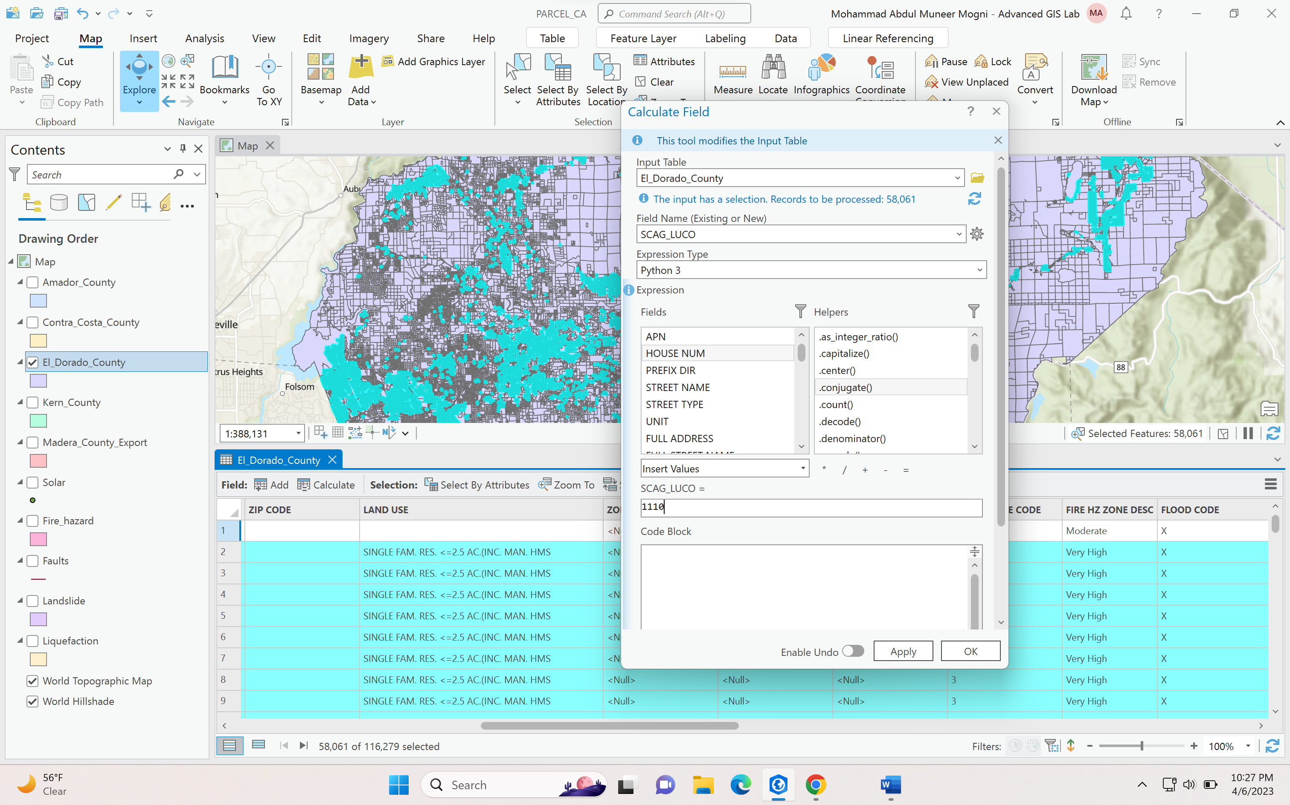

Now we have similar code to all single family homes

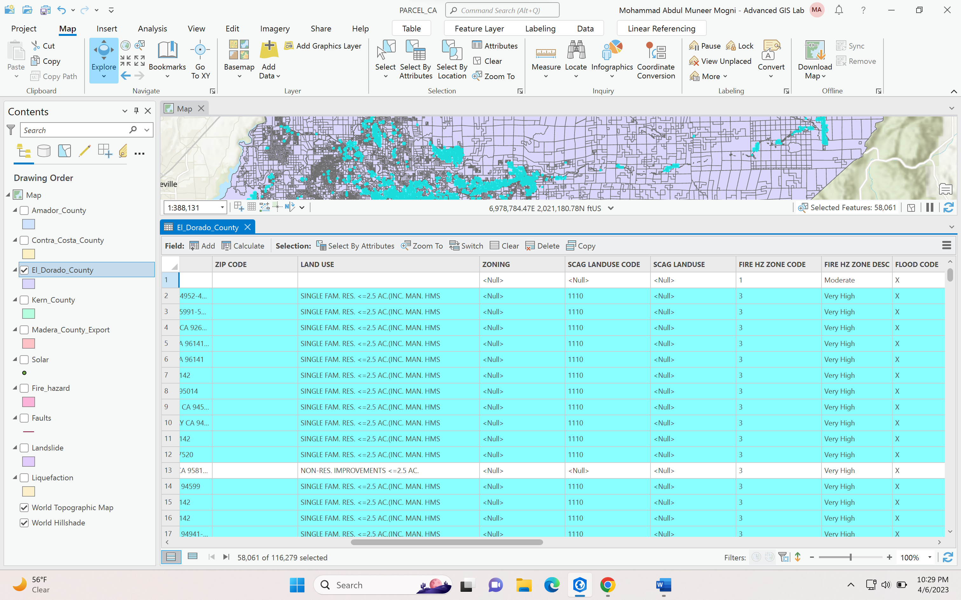

Simultaneously you can do for remaining SCAG CODES for multifamily and others.

II. Now moving on to second part of SCAG LAND USE inserting colors in the attribute table:

1. Go to select by attribute and Select the County

WHERE LAND USE IS EQUAL TO SINGLE FAMILY

Now you have selected a specific land use data

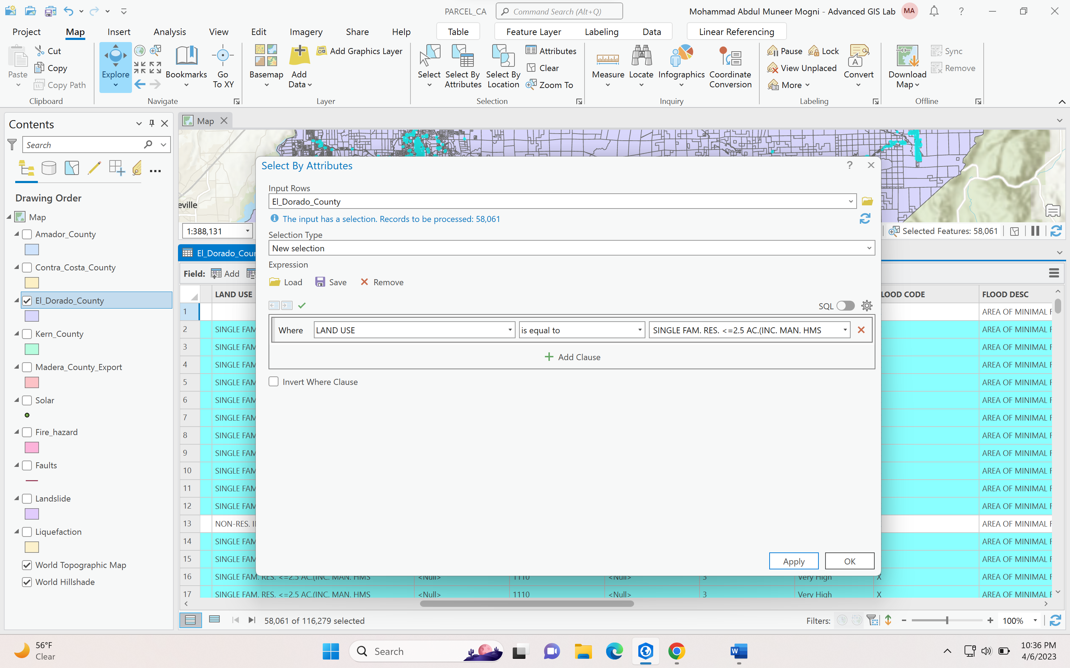

Go to Calculate drop box from the attribute table and select the field name as SCAG_LU which is for color codes and then search the template for color codes for single family homes which is #ffff00

and then enter those values in SCAG_LU = ‘#ffff00’ apply two quotations before the code

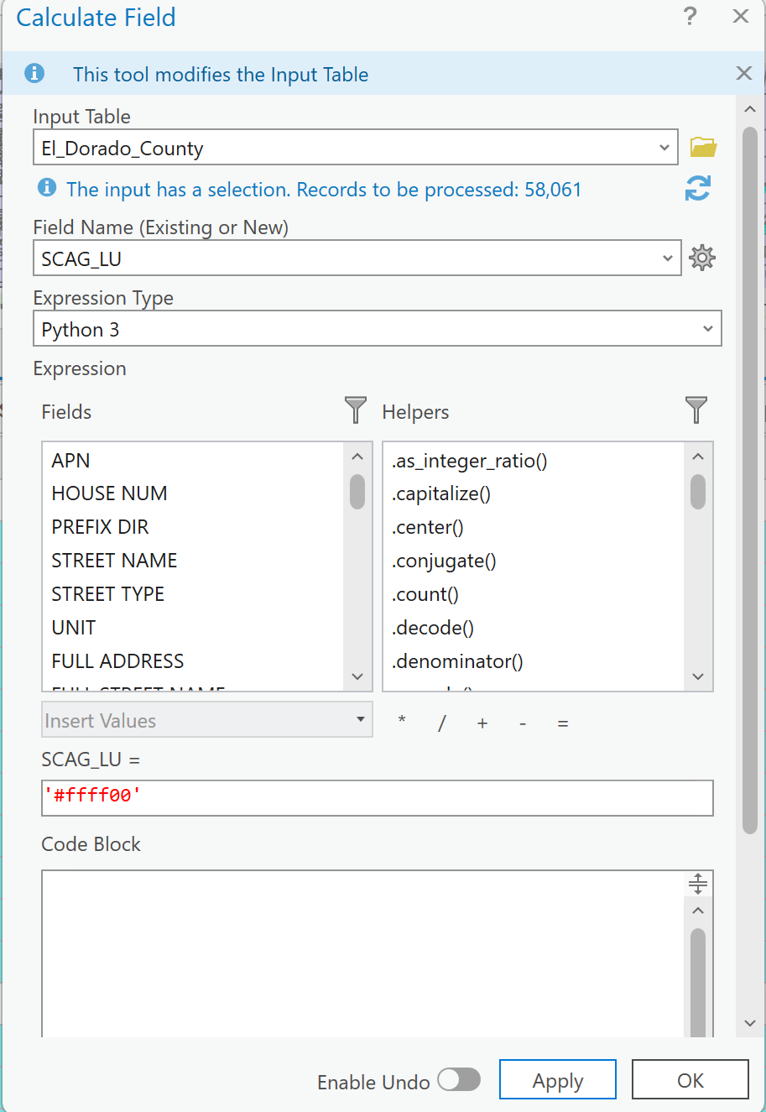

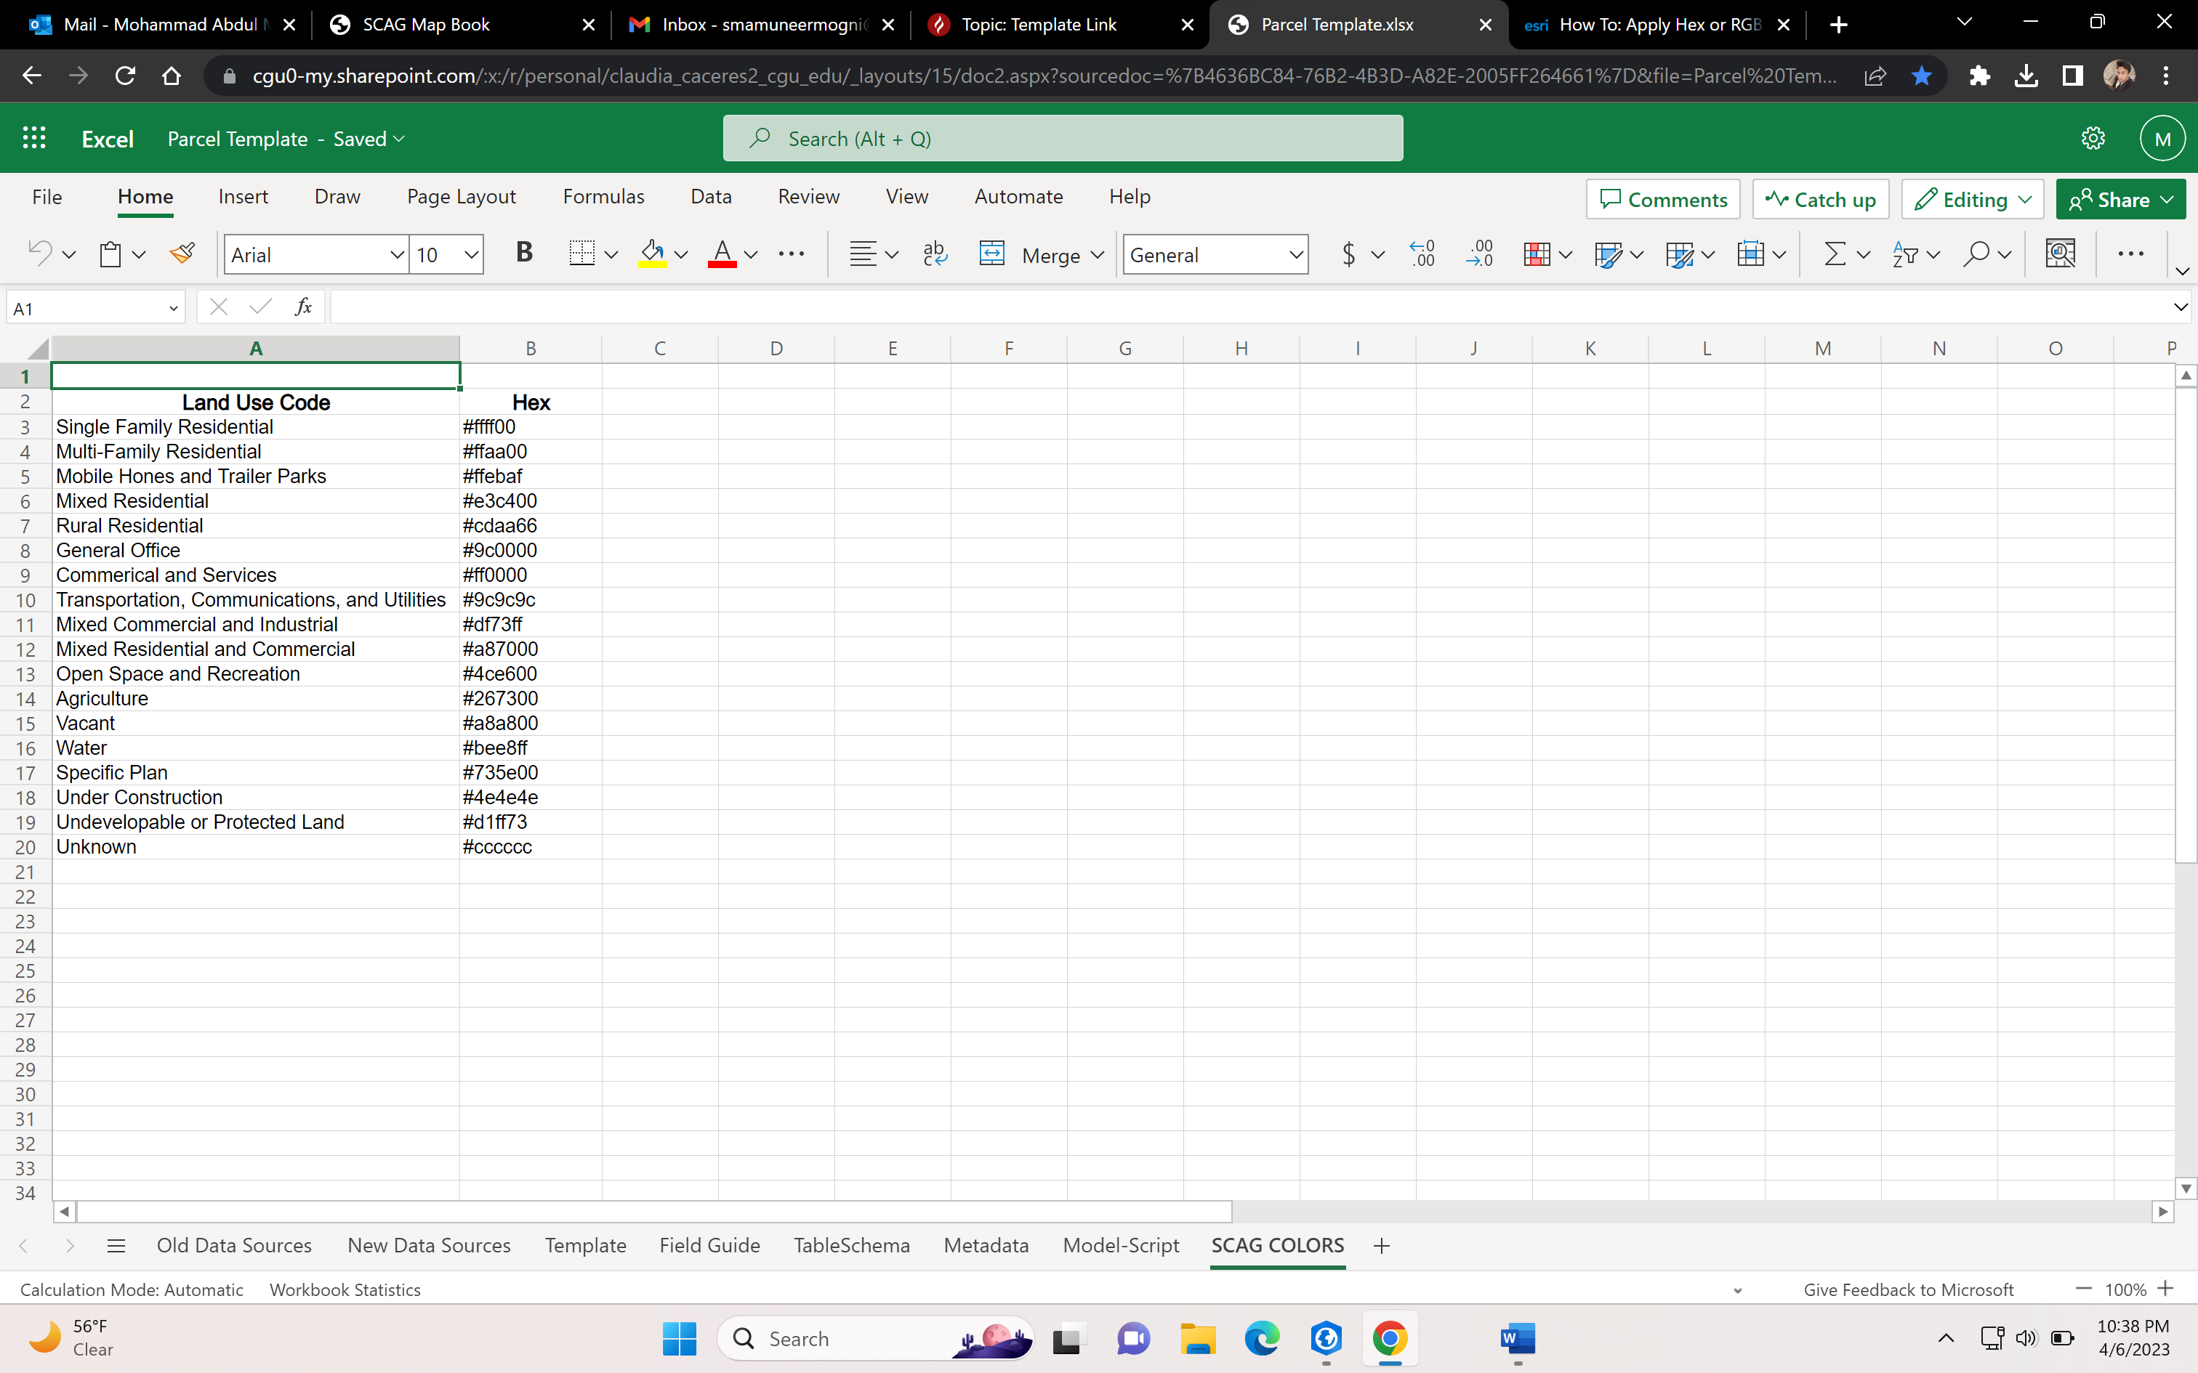

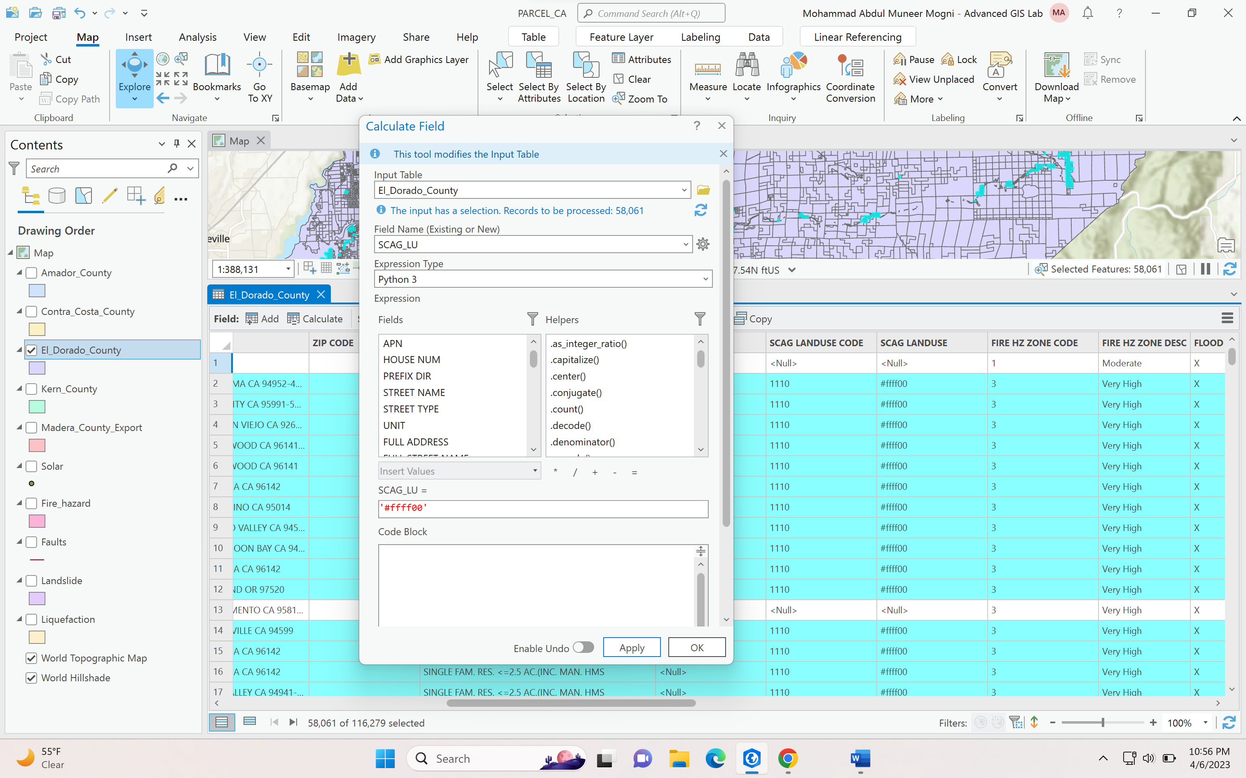

Results:



All the codes will be aligned to Single Family home

Save the Project

Next Step:

Clear all values

In the contents pane go to the county and right click and select Symbology

And then select vary symbology by attribute

Select Allow symbol property connections

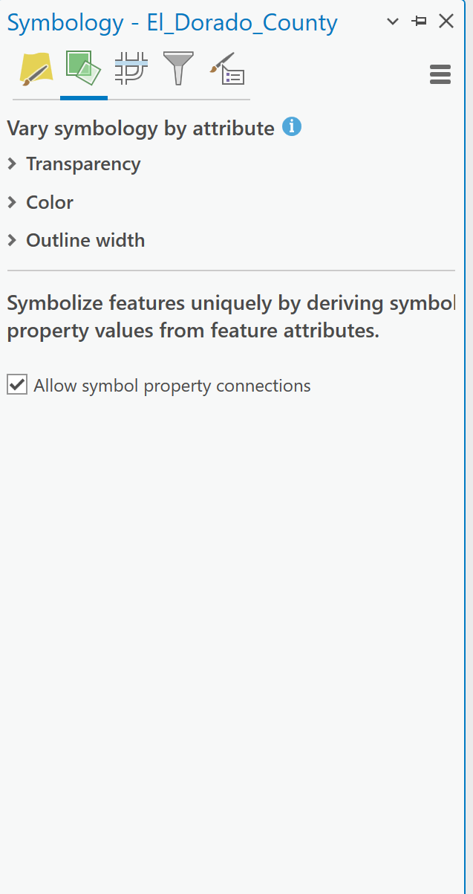

Then go to primary symbology

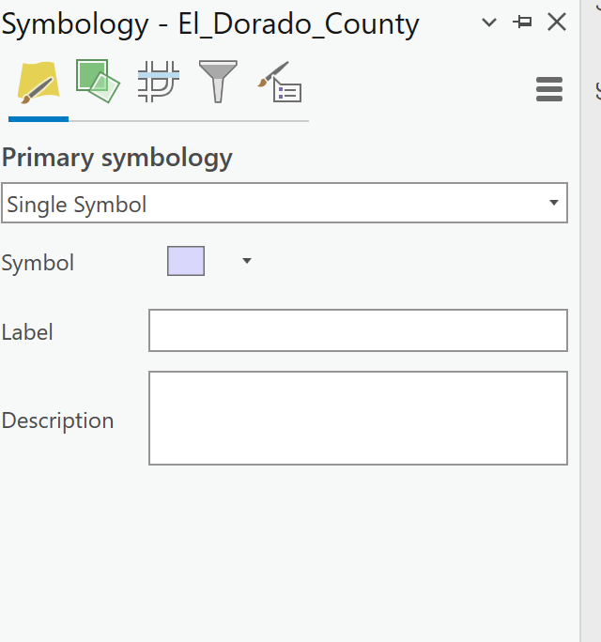

Click on the symbol color where the arrow is pointing in the above image

GO to properties

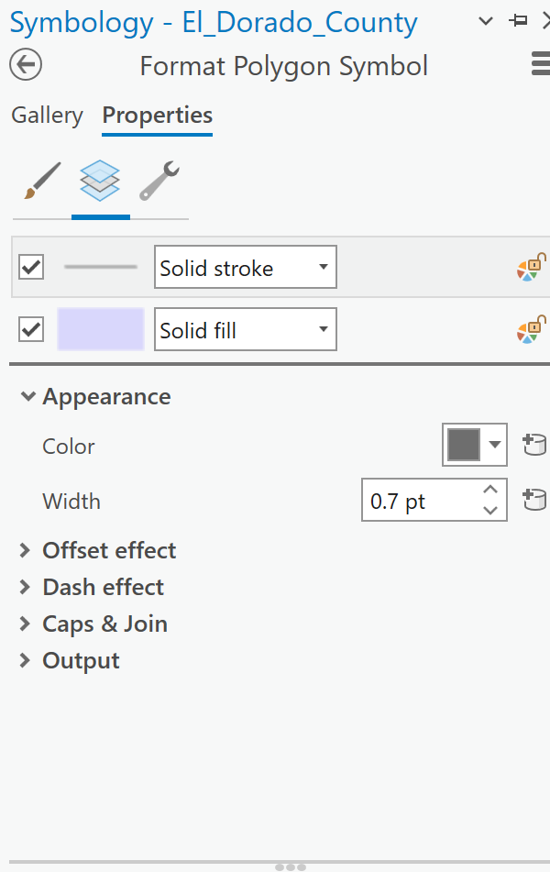

Then select the database symbol shown above in appearance

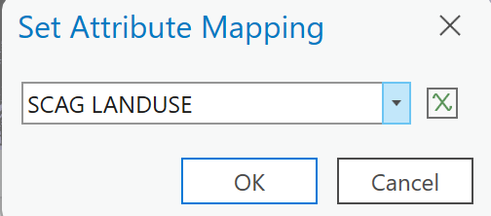

Now Set the attribute mapping to SCAG LANDUSE where we populated all the color codes

And then click apply

Save the project

FINAL RESULT :

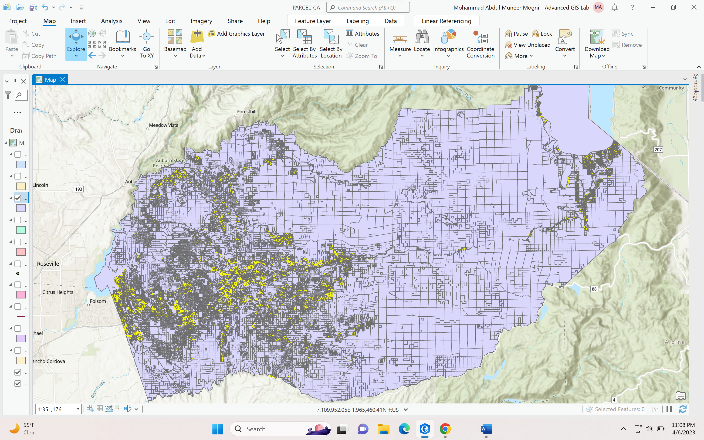

YELLOW PART SHOWS THE SINGLE FAMILY HOME